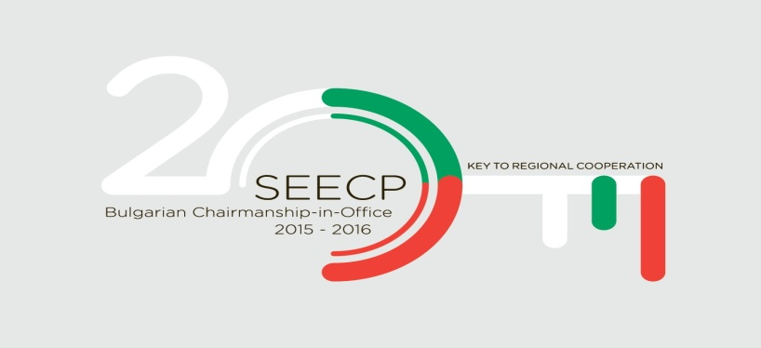

BULGARIAN CHAIRMANSHIP-IN-OFFICE
OF THE SOUTH-EAST EUROPEAN COOPERATION PROCESS
(SEECP)
/2015-2016/

JOINT DECLARATION
by Ministers in charge of labour and social policies of the SEECP Participants at the International Conference
“Facing the demographic challenges experienced by the SEECP participants”

12-13th May 2016
Sofia

We, Ministers and Heads of Delegations at the International Conference “Facing the demographic challenges experienced by the SEECP participants”, organized under the auspices of the Bulgarian Chairmanship-in-office of the SEECP /2015-2016/, in the presence of high level representatives of the Regional Cooperation Council, the United Nations Population Fund, the United Nations Economic Commission for Europe, the International Labour Office and the European Commission, met in Sofia on 12-13th May 2016 and discussed the management of demographic changes in South-Eastern Europe (SEE), labour migration and mobility in the region, youth employment, promotion of active ageing, solidarity between generations and transnational cooperation in the region.

In view of the above:

- Reiterating the objective to enhance regional cooperation in various fields as means to establish security, prosperity and stability in SEE, thereby improving the attractiveness of the region to other global players and investments;

- Confirming the role of the SEECP as a leading political format for regional cooperation in SEE, resolved to adhere to the principles of regional ownership and comprehensiveness, acting as good-neighbours to achieve substantial and coherent implementation of regional cooperation;

- Maintaining constructive dialogue between the SEECP and the Regional Cooperation council in guiding SEECP participants towards a result-oriented regional cooperation and reinforcing the European Union membership perspective of the countries in SEE;

- Determined to safeguard the fundamental freedoms and the essential values of democracy, rule of law and respect for human rights, as a prerequisite to economic and social progress and a step forward to advancing cooperation between states;

Whereas:

- The main demographic challenges for most SEECP participants are associated predominantly with long-term trends of decreasing and ageing population and workforce due to changes in the processes of fertility, mortality and migration.

- Demographic challenges and changes affect many areas of economic and social life and have significant impact on public finances and the proper functioning of social systems, including the labour market, the social security system, healthcare and education.

- Addressing demographic challenges means providing a better environment for childbirth, raising and educating children, achieving a better level of material well-being, standard of living and quality of life, reaching higher productivity, overcoming inequalities, implementing a reasonable and adequate labour migration policy and making full use of the potential for the social and economic participation of all groups in societies.

- Preparation to address demographic challenges is important in order to achieve sustainable development and inclusive growth, competitive social market economy with high levels of quality employment, social cohesion and solidarity between generations.

We have agreed on the following:

- To adopt a holistic and long-term strategic approach to the management of demographic changes in terms of mutual coordination of all stakeholders - including government institutions at national, regional and local level, social partners, academic and research organisations, civil society organisations.

- To adopt a positive approach to the demographic challenges that encompasses the entire life cycle of the individual, focuses on the use of the potential of all generations and promotes solidarity between generations.

- To support initiatives to facilitate transnational dialogue between SEECP participants that are affected by current demographic changes in order to identify common activities; to achieve effective regulation of labour migration flows; to establish and maintain areas/regions/cities for sustainable development and inclusive growth.

- To support activities that improve the quality of human resources and promote labour mobility, education, training and retraining, enhance knowledge, qualification and skills; provide lifelong learning, etc.

- To support initiatives related to job creation and raising the level of quality employment for all citizens, poverty reduction, prevention of undeclared work, modernisation of labour market institutions, overcoming inequalities and improving access to the labour market.

- To support and promote quality youth employment and active and independent living of the elderly and people with disabilities and improve the opportunities for equal access and participation in the labour market, social services and care, volunteering, reconciling professional and family/private life; and transfer of knowledge and skills between generations.
We take commitment to:

- Support measures for specific training in demographic policy design and for building the administrative capacity needed to properly address demographic challenges in terms of: joint coordination; exchanges of experience and good practices; and transfer of knowledge and know-how to meet demographic challenges.
This may be accomplished by:
a) Creating a long-term vision for balanced development of population and creation of a transnational regional mechanism to monitor labour migration and mobility, sustainable development of regions and cities and reduction of inter-regional disparities;
b) Developing and participating in transnational projects and project activities funded within the framework of sustainable initiatives, programmes, funds and other financial instruments of the European Union, the United Nations, the United Nations Population Fund and other bodies and organisations;
c) Developing cooperation in relevant fields with international agencies such as the International Labour Organization and other organizations;
d) Building and maintaining a transnational network of high-level experts for long-term cooperation with exchange of experiences and good practices to meet the demographic challenges and encourage the development of labour markets and labour migration/mobility for sustainable development and growth;
e) Establishing and maintaining a web-based platform for information, communication and knowledge sharing on the state, the movement of population and the labour force in the region;
f) Synchronising and improving statistics on the regional impact of demographic changes and population movement by collecting and systematising existing knowledge on demographic changes and migration, as well as their potential effects on human capital and sustainable development of regions and cities;
g) Developing and implementing a modular training programme for exchange of experience and good practices on “Management of demographic changes and workforce development” and organizing other events and initiatives that will maintain and enhance the capacity of public administrations to manage demographic changes, which includes involvement of eminent speakers and practitioners from different countries through the specialised Centre for Human Resources Development and Regional Initiatives of the Republic of Bulgaria;
h) Developing a Communication Plan with measures for communication, dissemination and transfer of knowledge between the SEECP participants.

- We express our appreciation to the Government of the Republic of Bulgaria for the hospitality and extend our warmest gratitude for hosting and the excellent organization of this conference within the Chairmanship-in-Office of SEECP (2015-2016).

- We welcome the incoming Chairmanship-in-Office of the Republic of Croatia and trust that the topic of the conference and the engagements in this Declaration will be kept as one of the priorities on its agenda, as well as of future Chairmanships-in-Office.

Adopted in Sofia, 13th May 2016

